# Tutorial Artifacts

This artifact captures study notes that informed my understanding of key concepts and syntax. These notes guided decisions during implementation and served as quick references (see Figure 1).

GitHub link to full document :

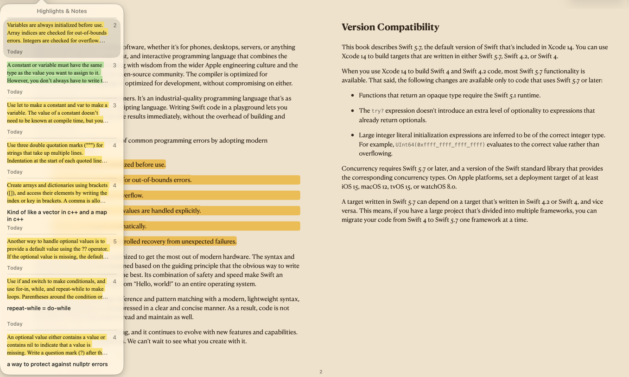Figure 1: “The Swift Programming Language” Notes

This artifact documents a milestone in the project. It explains progress and how it fits into the overall deliverable (see Figure 2).

GitHub link to full document :

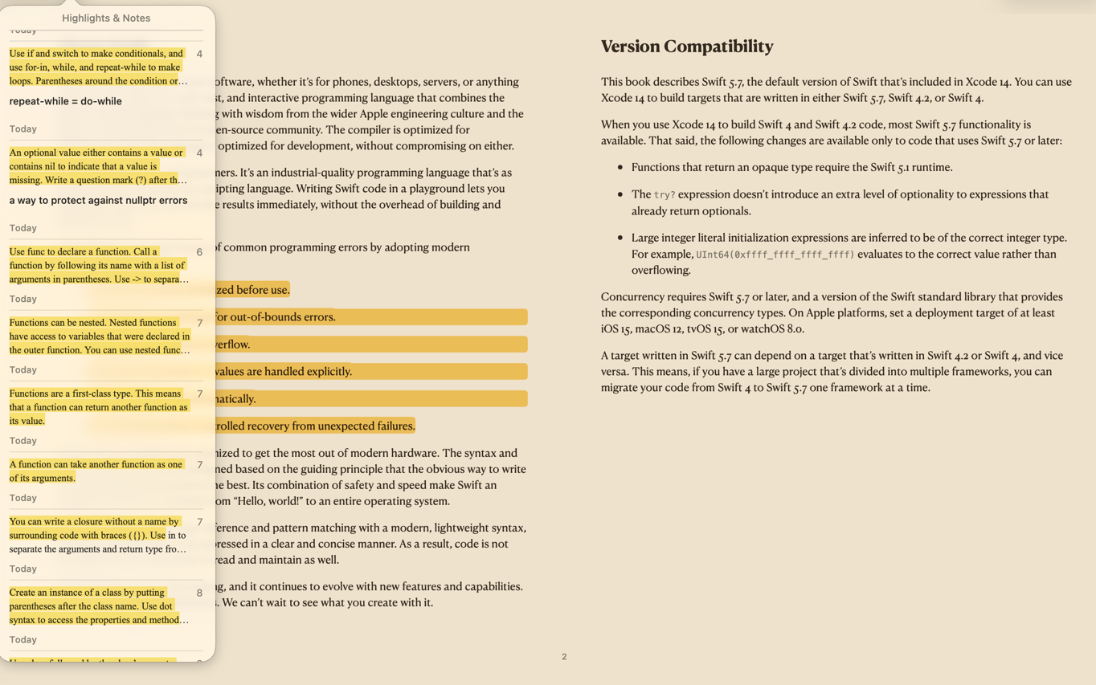Figure 2: Artifact 2

This artifact captures study notes that informed my understanding of key concepts and syntax. These notes guided decisions during implementation and served as quick references (see Figure 3).

GitHub link to full document :

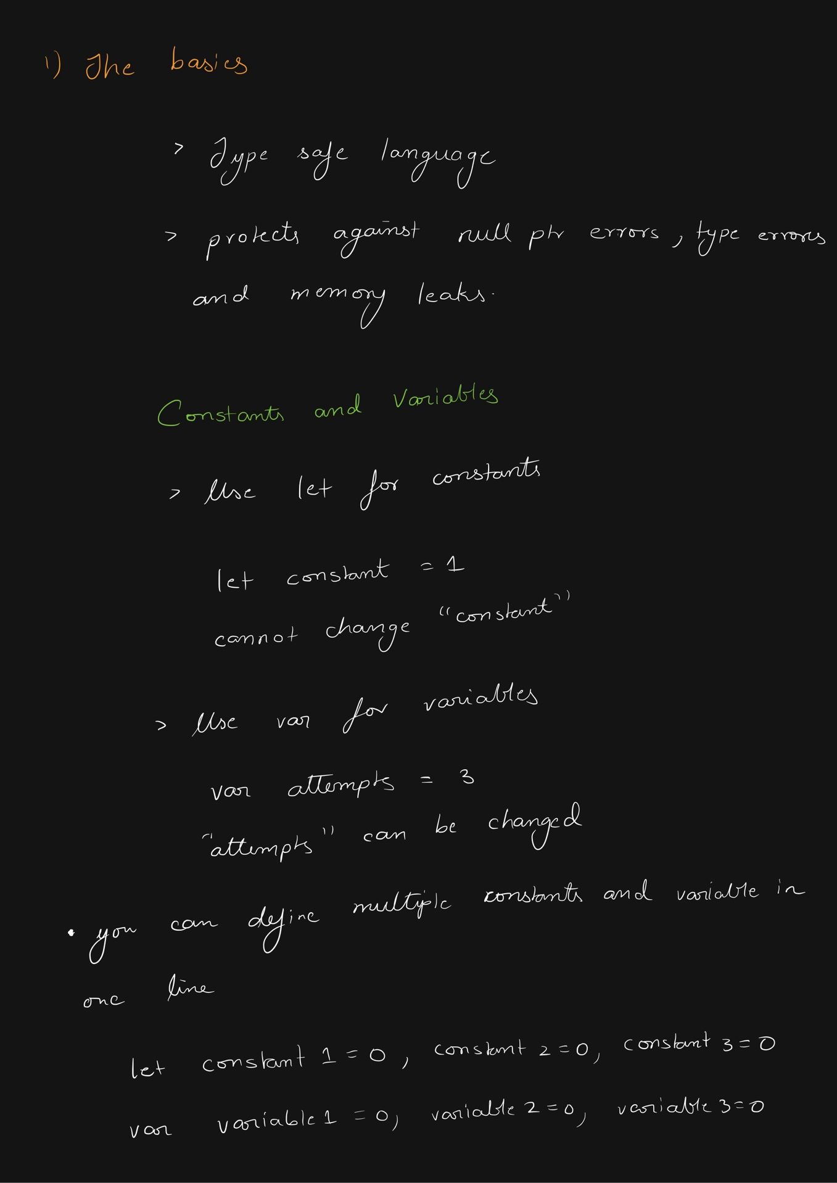

Figure 3: Notes of the “The Swift Programming Language”. Only included four pages to avoid clutter.

This artifact documents a milestone in the project. It explains progress and how it fits into the overall deliverable (see Figure 4).

GitHub link to full document :

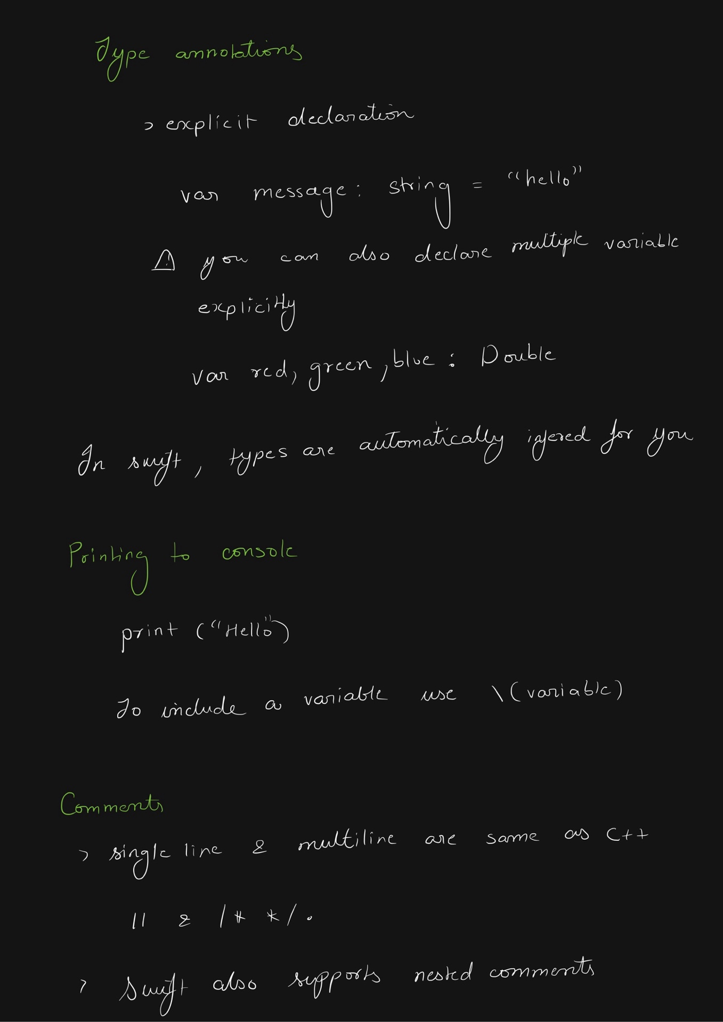

Figure 4: Artifact 4

This artifact documents a milestone in the project. It explains progress and how it fits into the overall deliverable (see Figure 5).

GitHub link to full document :

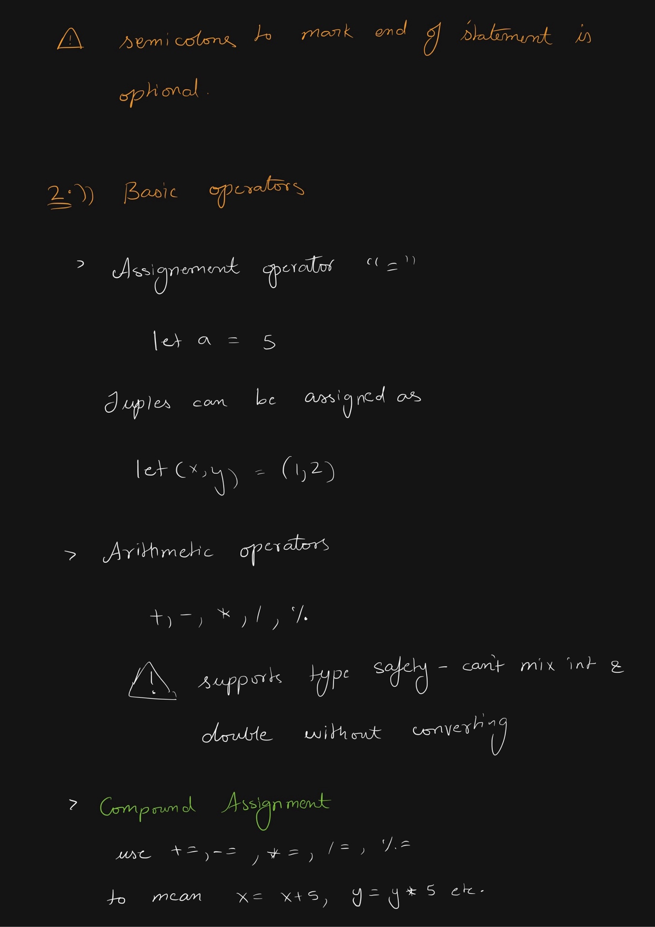

Figure 5: Artifact 5

This artifact documents a milestone in the project. It explains progress and how it fits into the overall deliverable (see Figure 6).

GitHub link to full document :

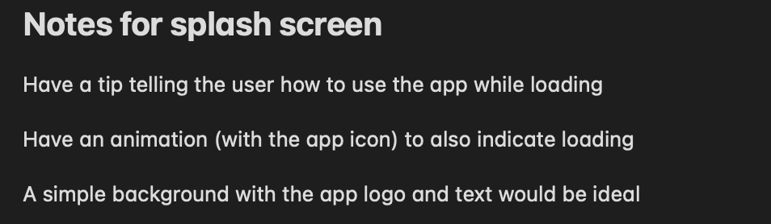Figure 6: Artifact 6

This artifact documents a milestone in the project. It explains progress and how it fits into the overall deliverable (see Figure 7).

GitHub link to full document :

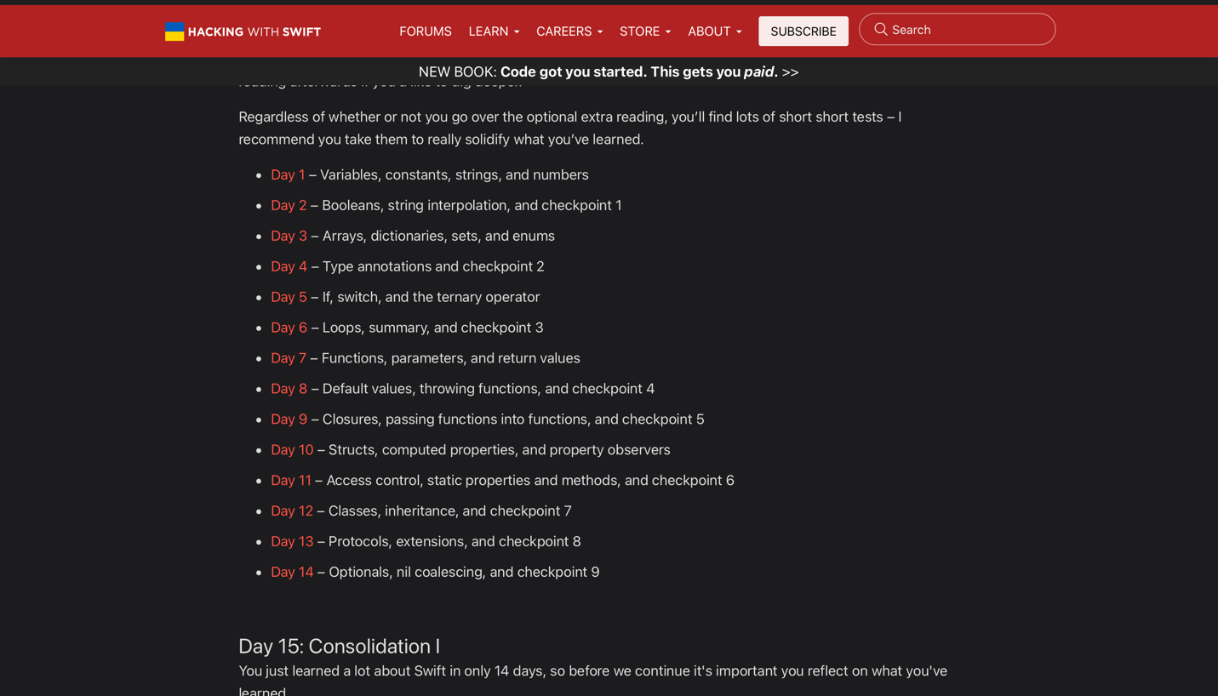Figure 7: Artifact 7

This artifact documents a milestone in the project. It explains progress and how it fits into the overall deliverable (see Figure 8).

GitHub link to full document :

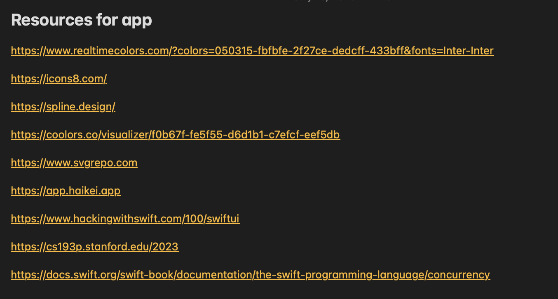Figure 8: Artifact 8

This artifact documents a milestone in the project. It explains progress and how it fits into the overall deliverable (see Figure 9).

GitHub link to full document :

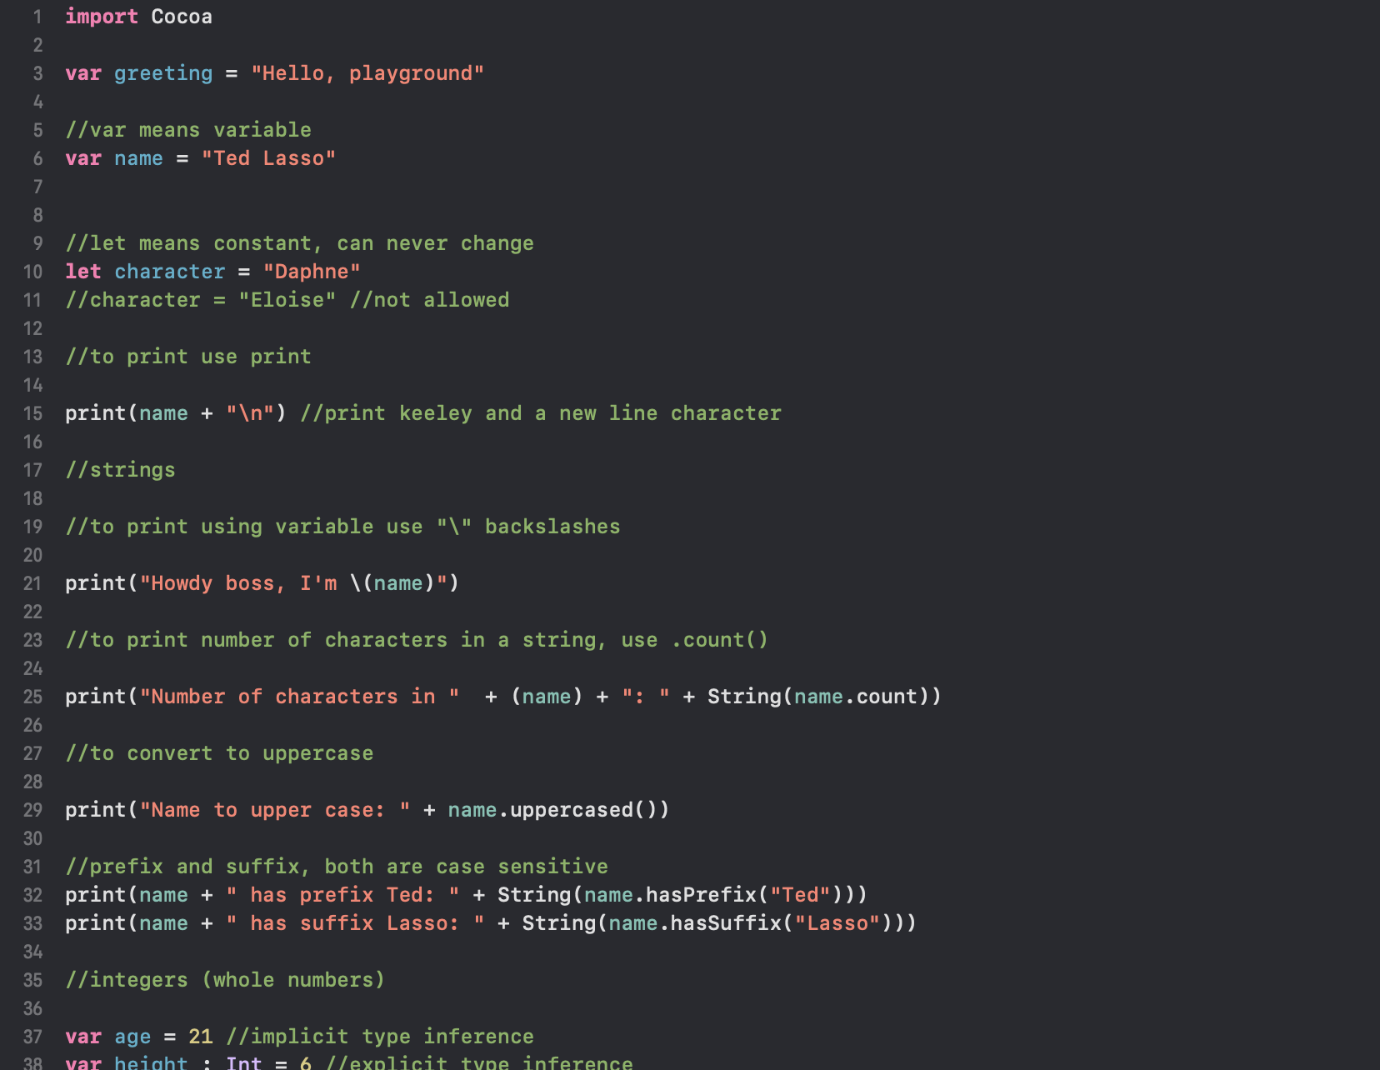Figure 9: Artifact 9

This artifact documents a milestone in the project. It explains progress and how it fits into the overall deliverable (see Figure 10).

GitHub link to full document :

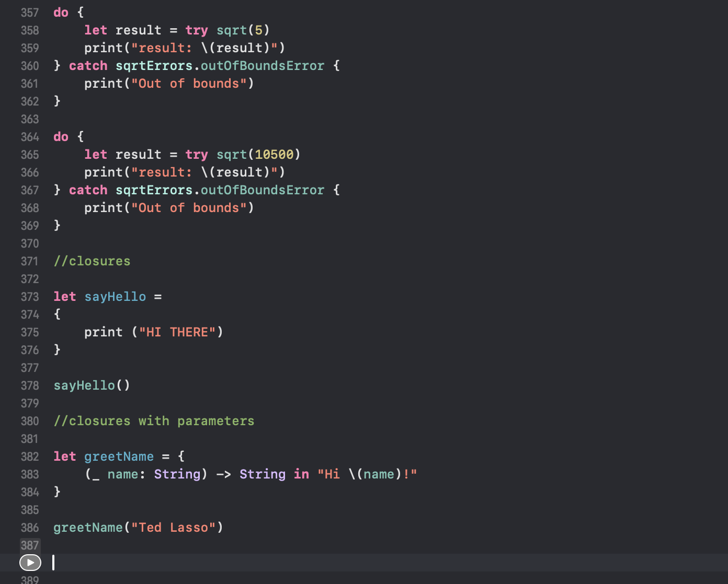Figure 10: Artifact 10

This artifact is a Swift Playgrounds session where I practiced concepts from tutorials/books. It demonstrates hands-on validation of ideas before adding them to the app (see Figure 11).

GitHub link to full document :

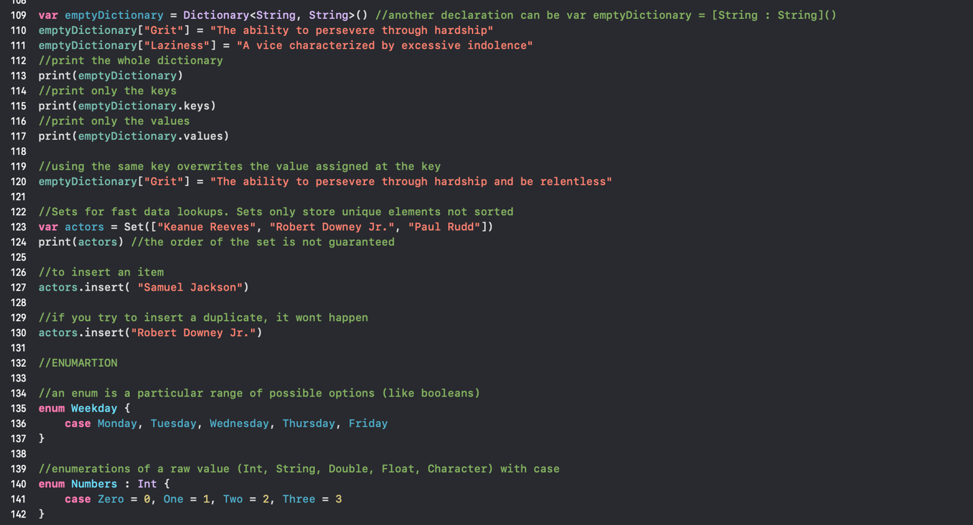Figure 11: Swift Playground Screenshot #1 showcasing me practicing the concepts as I learn from the book

This artifact is a Swift Playgrounds session where I practiced concepts from tutorials/books. It demonstrates hands-on validation of ideas before adding them to the app (see Figure 12).

GitHub link to full document :

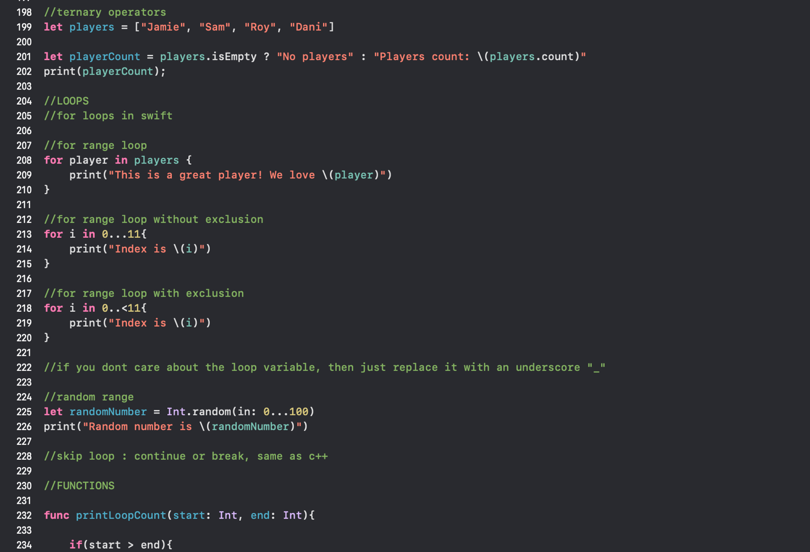Figure 12: Swift Playground Screenshot #2 showcasing me practicing the concepts as I learn from the book

This artifact shows progress through structured learning resources. These lessons directly shaped code structure and UI patterns in the app (see Figure 13).

GitHub link to full document :

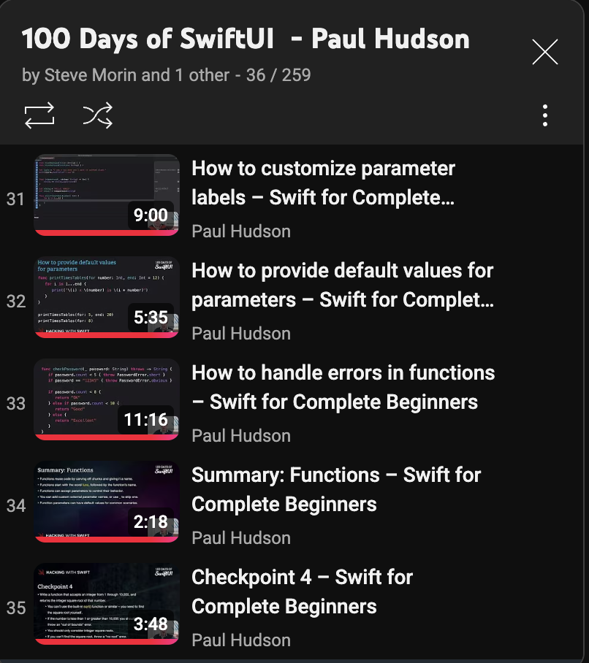

Figure 13: Youtube playlist progress of “hackingwithswift” screenshot #1

This artifact shows progress through structured learning resources. These lessons directly shaped code structure and UI patterns in the app (see Figure 14).

GitHub link to full document :

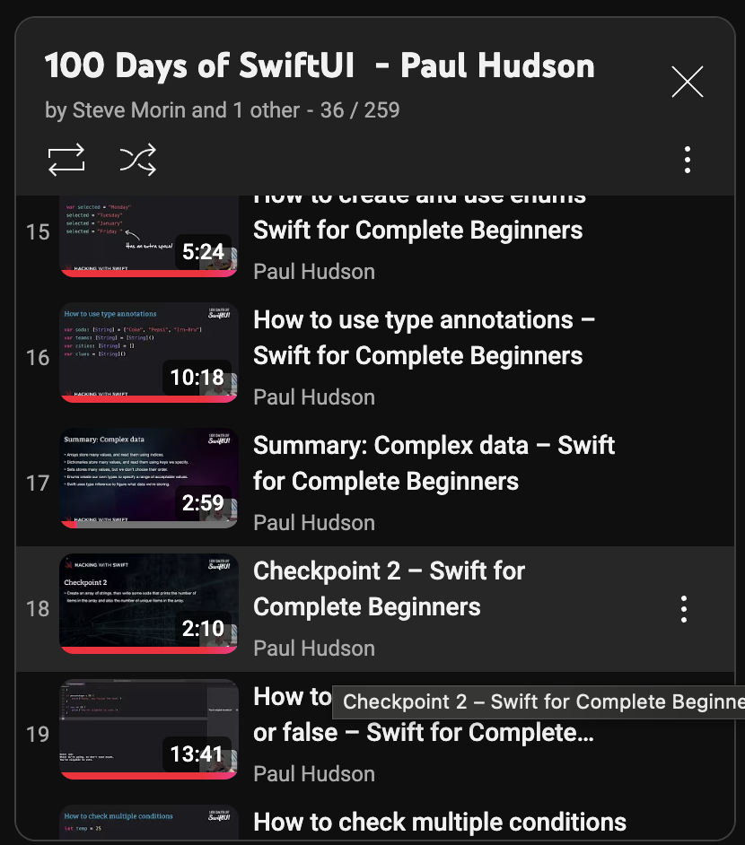Figure 14: Youtube playlist progress of “hackingwithswift” screenshot #2

This artifact shows progress through structured learning resources. These lessons directly shaped code structure and UI patterns in the app (see Figure 15).

GitHub link to full document :

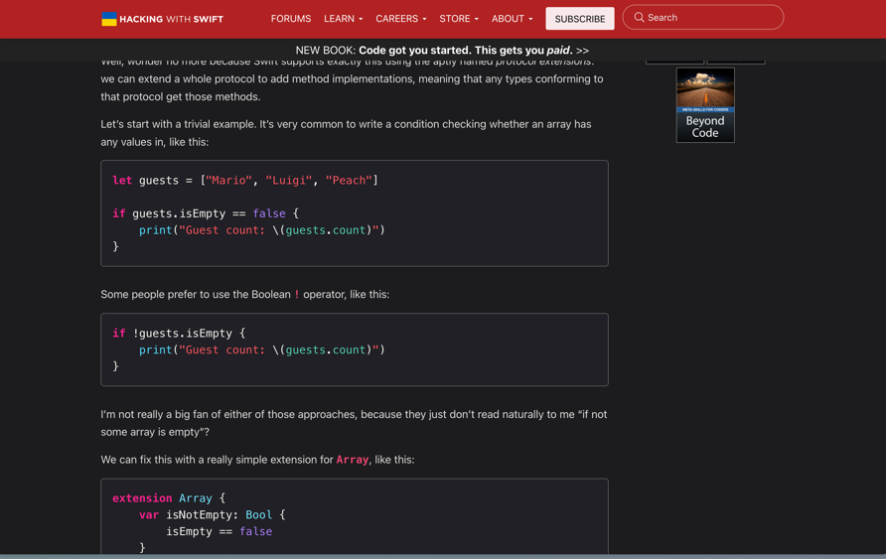

Figure 15: Hacking With Swift #1

This artifact shows progress through structured learning resources. These lessons directly shaped code structure and UI patterns in the app (see Figure 16).

GitHub link to full document :

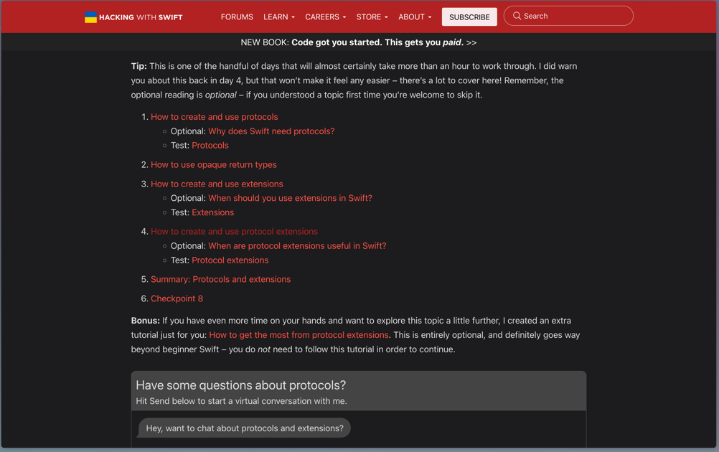

Figure 16: Hacking With Swift #2

This artifact shows progress through structured learning resources. These lessons directly shaped code structure and UI patterns in the app (see Figure 17).

GitHub link to full document :

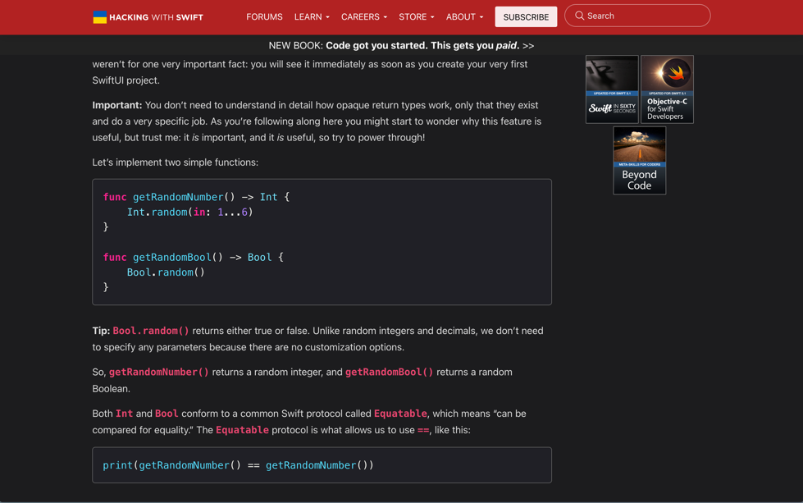

Figure 17: Hacking With Swift #3

# App Development Artifacts

This artifact documents the development environment setup in Xcode. It marks the transition from learning to building the project (see Figure 18).

GitHub link to full document :

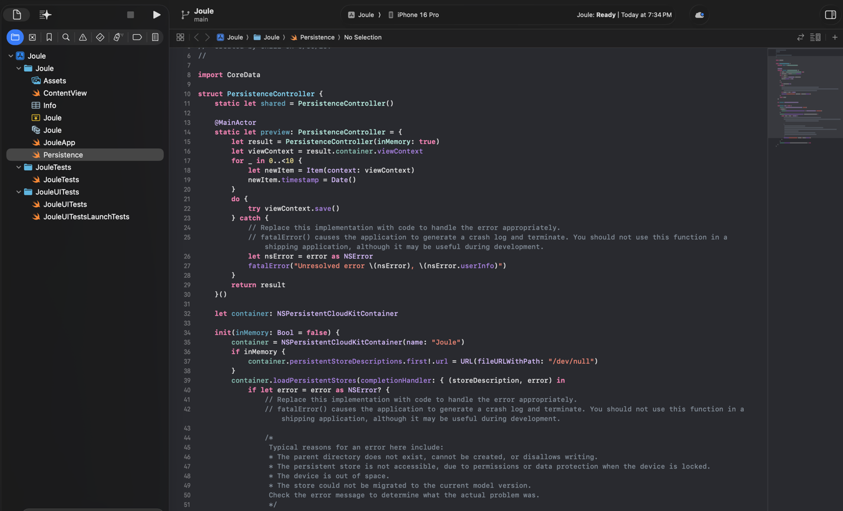Figure 18: XCode Setup

This artifact comes from my Figma workspace where I shaped wireframes and flows. It ensured clarity before coding views in SwiftUI (see Figure 19).

GitHub link to full document :

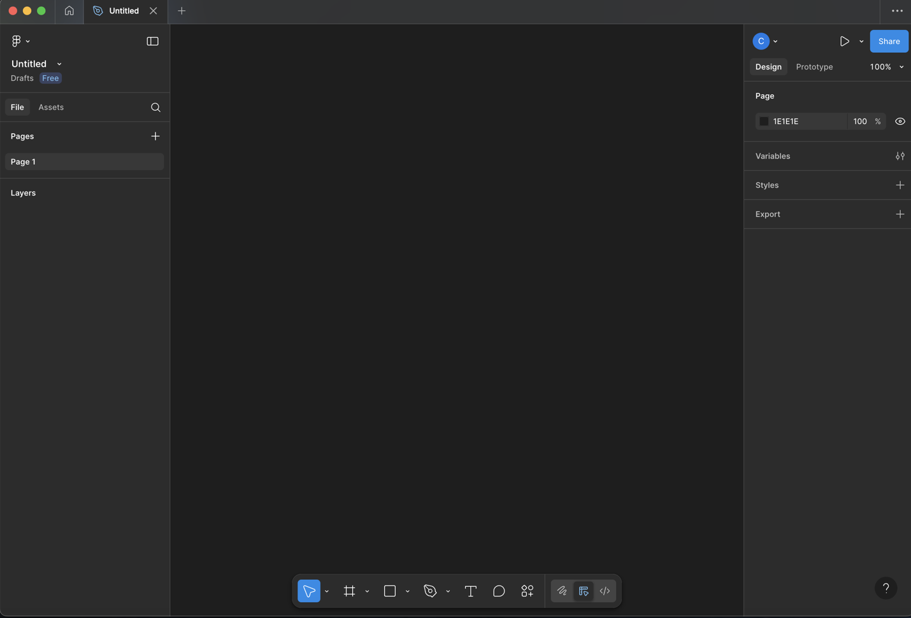Figure 19: Figma Setup

This artifact captures study notes that informed my understanding of key concepts and syntax. These notes guided decisions during implementation and served as quick references (see Figure 20).

GitHub link to full document :

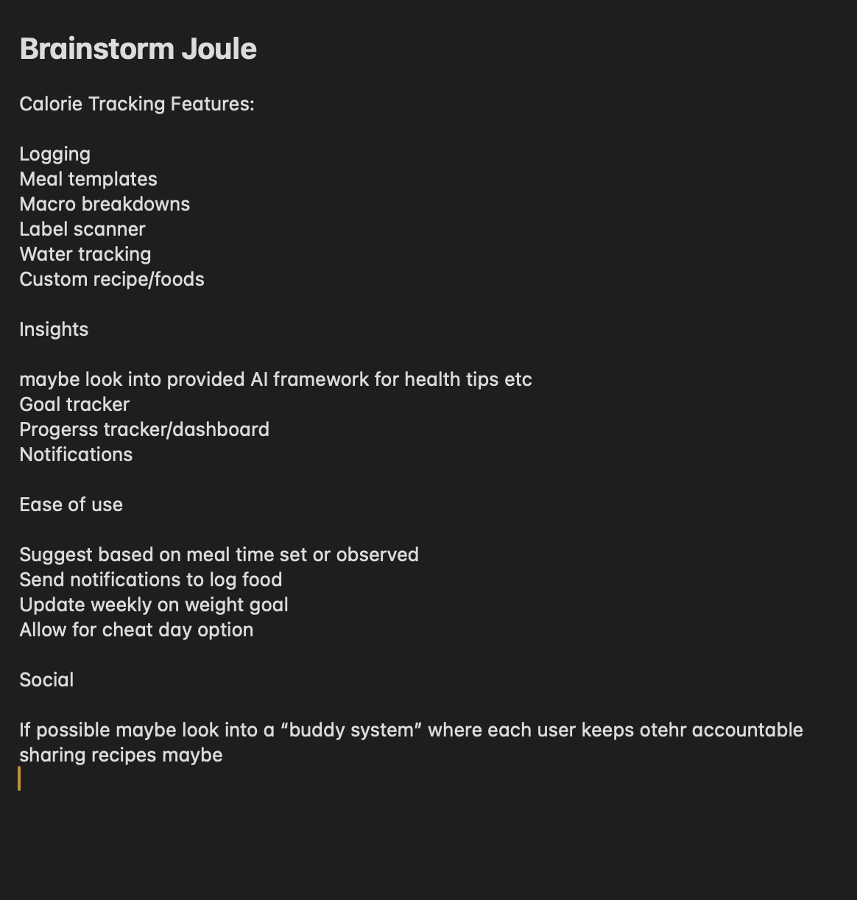Figure 20: Brainstorming Notes

This artifact documents a milestone in the project. It explains progress and how it fits into the overall deliverable (see Figure 21).

GitHub link to full document :

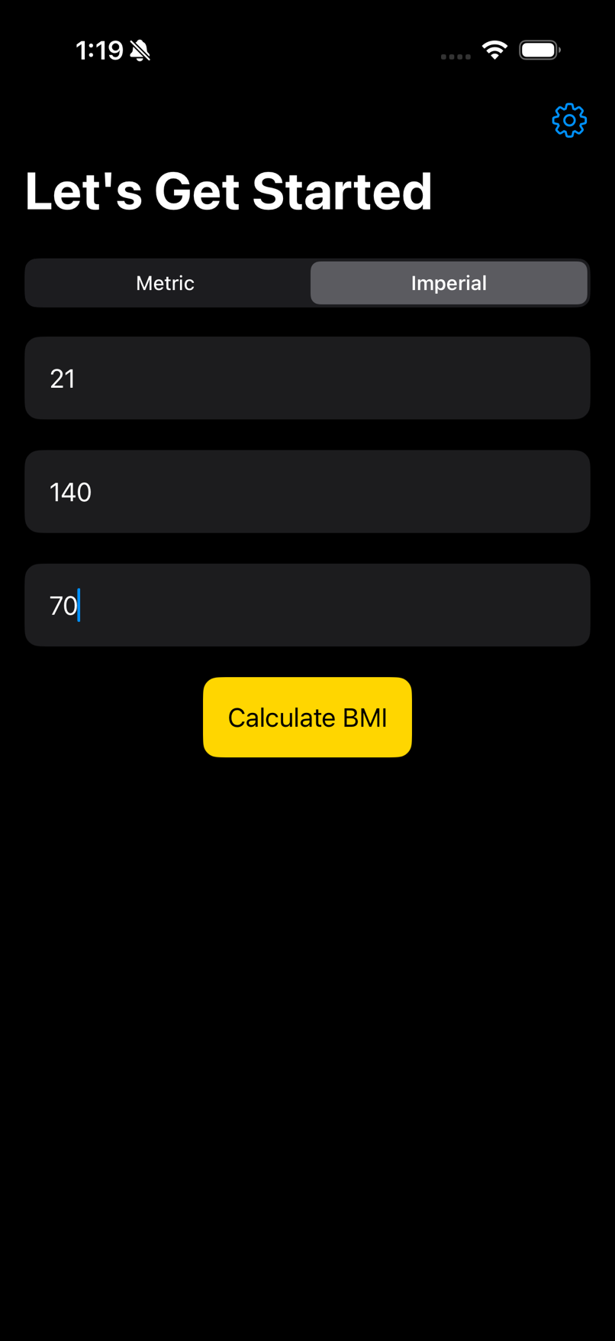

Figure 21: Screenshots of features implemented in app. Additional evidence can be found in showcase #2 presentation slides.

This artifact documents a milestone in the project. It explains progress and how it fits into the overall deliverable (see Figure 22).

GitHub link to full document :

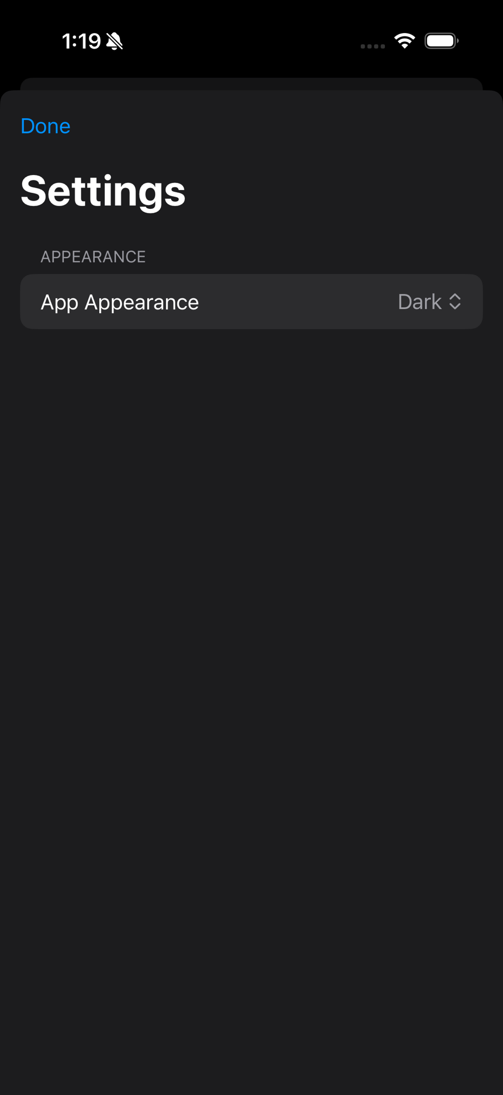

Figure 22: Artifact 22

This artifact documents a milestone in the project. It explains progress and how it fits into the overall deliverable (see Figure 23).

GitHub link to full document :



Figure 23: Artifact 23

This artifact documents a milestone in the project. It explains progress and how it fits into the overall deliverable (see Figure 24).

GitHub link to full document :

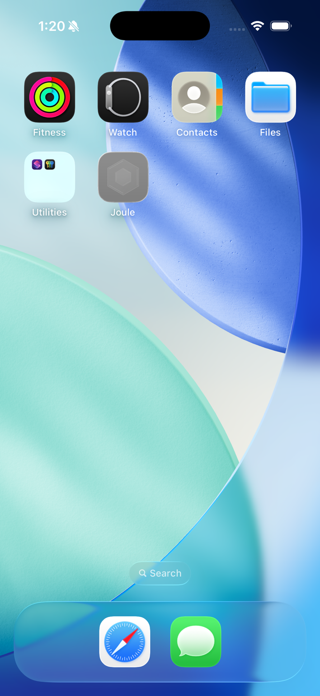

Figure 24: Artifact 24

This artifact shows progress through structured learning resources. These lessons directly shaped code structure and UI patterns in the app (see Figure 25).

GitHub link to full document :

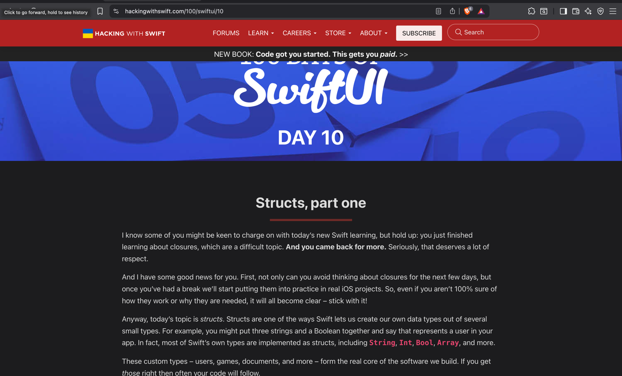Figure 25: Hacking with swiftUI screenshot #1

This artifact documents a milestone in the project. It explains progress and how it fits into the overall deliverable (see Figure 26).

GitHub link to full document :

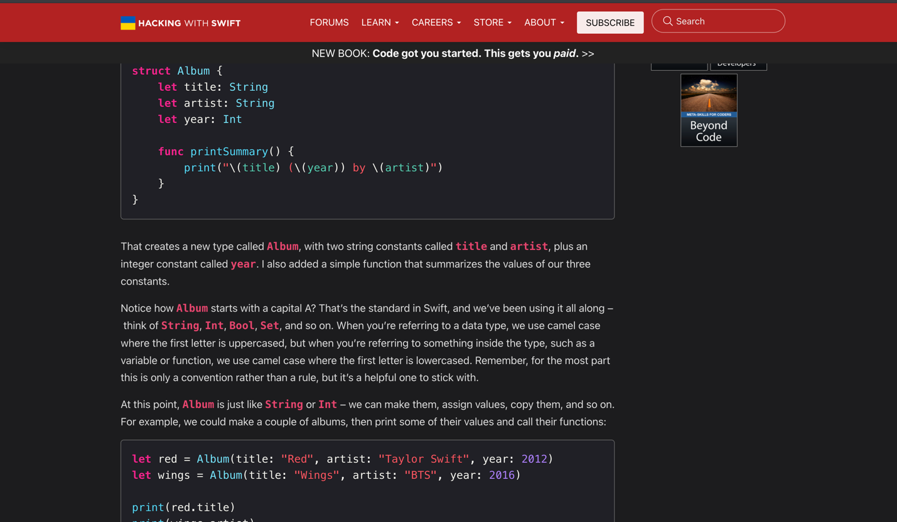Figure 26: Artifact 26

This artifact shows progress through structured learning resources. These lessons directly shaped code structure and UI patterns in the app (see Figure 27).

GitHub link to full document :

Figure 27: Hacking with swiftUI screenshot #2 & #3

This artifact documents a milestone in the project. It explains progress and how it fits into the overall deliverable (see Figure 28).

GitHub link to full document :

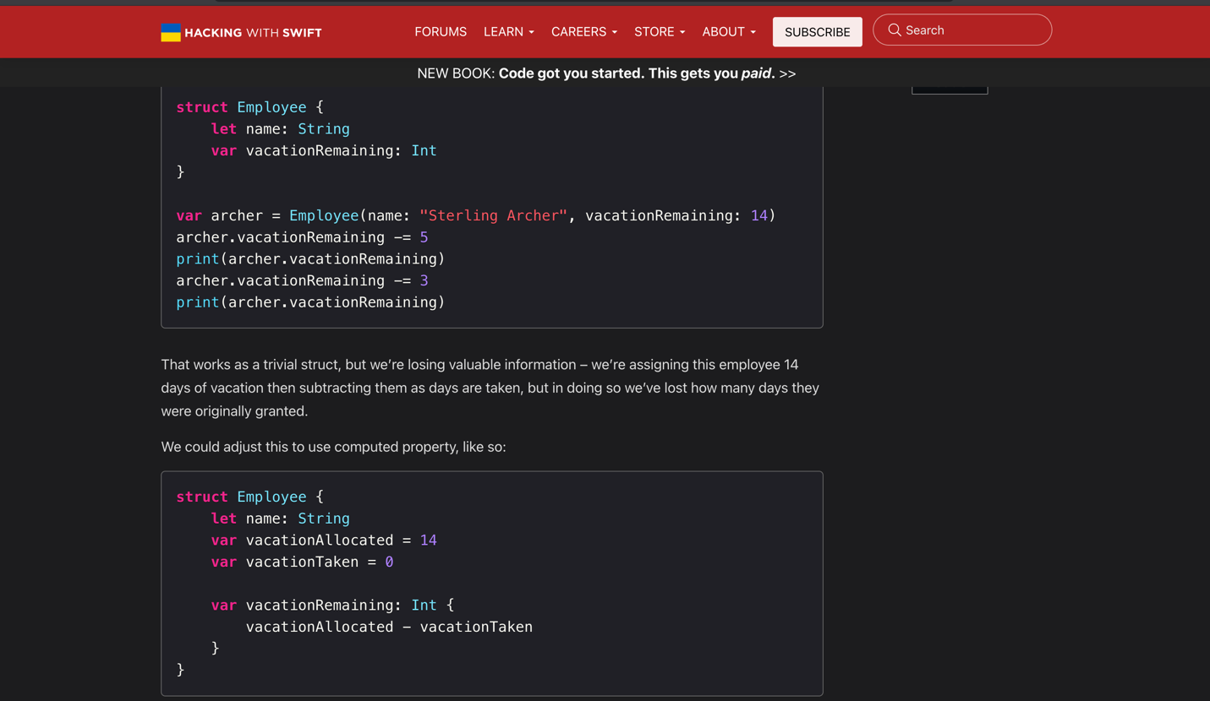Figure 28: Artifact 28

This artifact shows project timeline and storage decisions. It supports planning and data management choices in the app (see Figure 29).

GitHub link to full document :

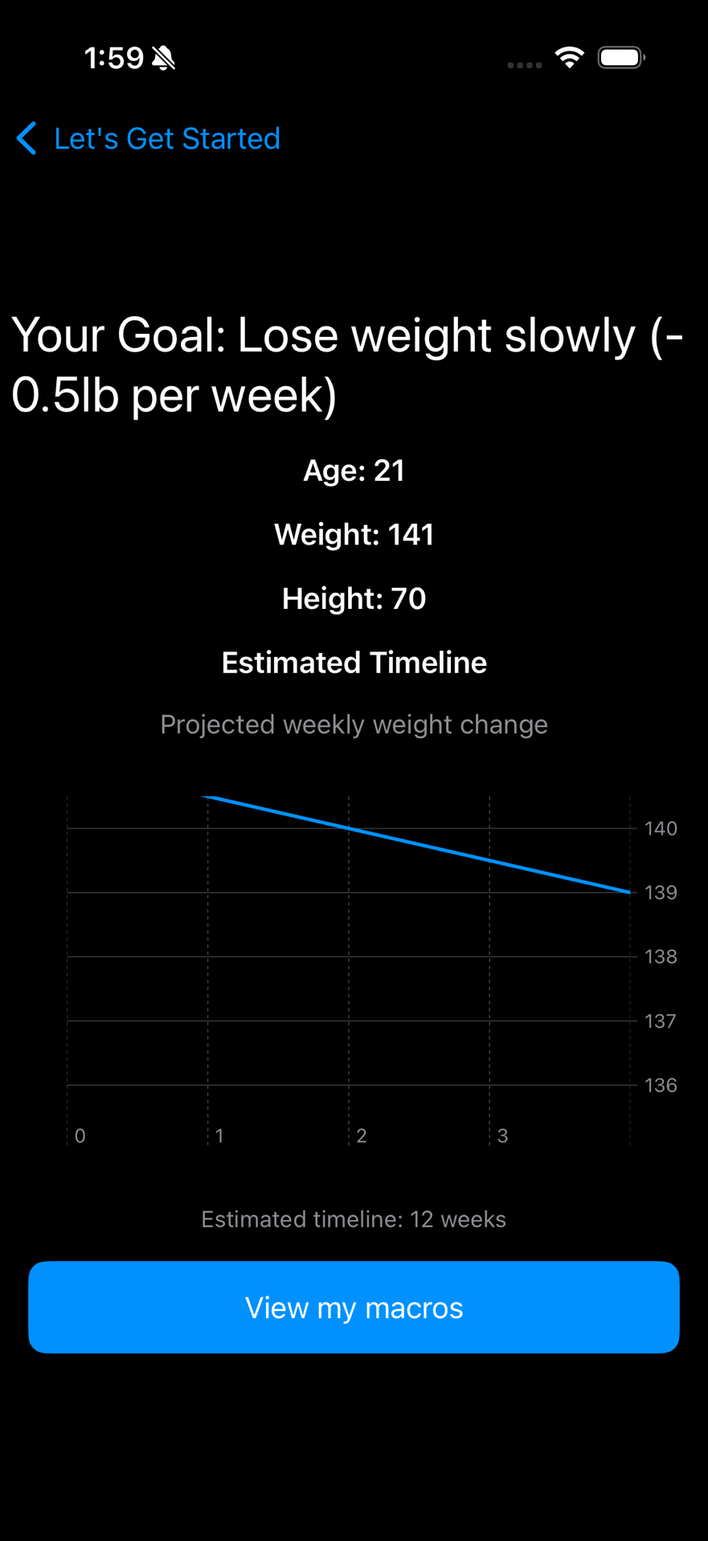

Figure 29: Timeline and app storage screenshot

This artifact highlights the nutrition macro feature and its controls. It ties UI inputs to state and feedback loops for the user (see Figure 30).

GitHub link to full document :

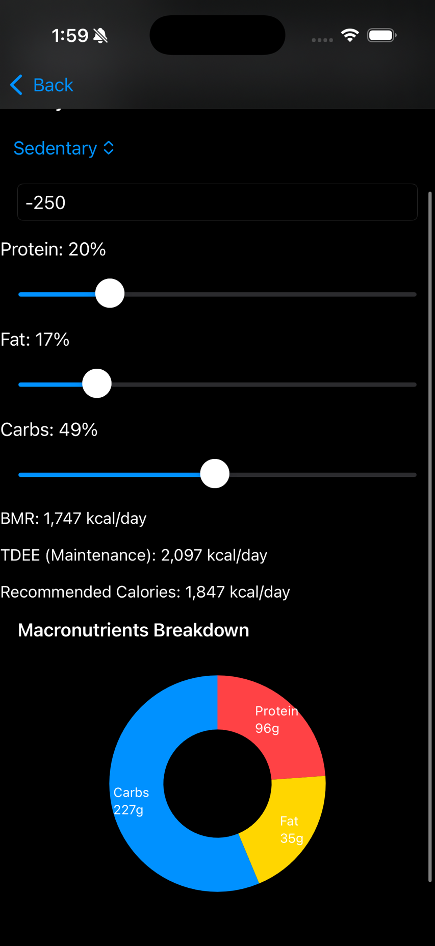

Figure 30: Macro page screenshot with adjustable sliders

This artifact highlights the nutrition macro feature and its controls. It ties UI inputs to state and feedback loops for the user (see Figure 31).

GitHub link to full document :

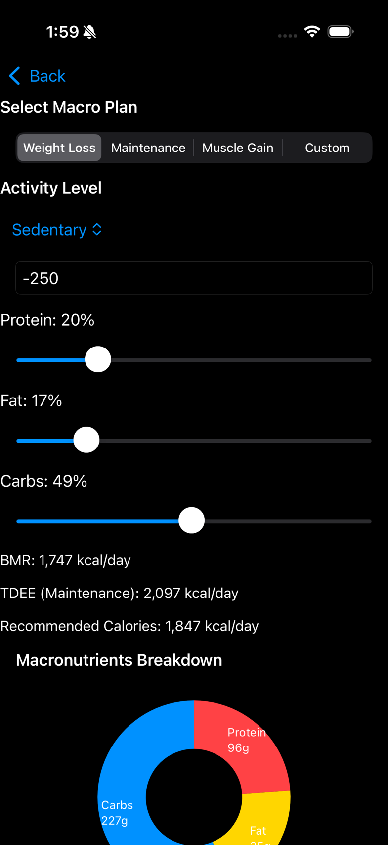

Figure 31: Macro page with selectable macro plans

This artifact demonstrates automatic unit conversion and goal display on the home page. It improves usability and keeps goals visible (see Figure 32).

GitHub link to full document :

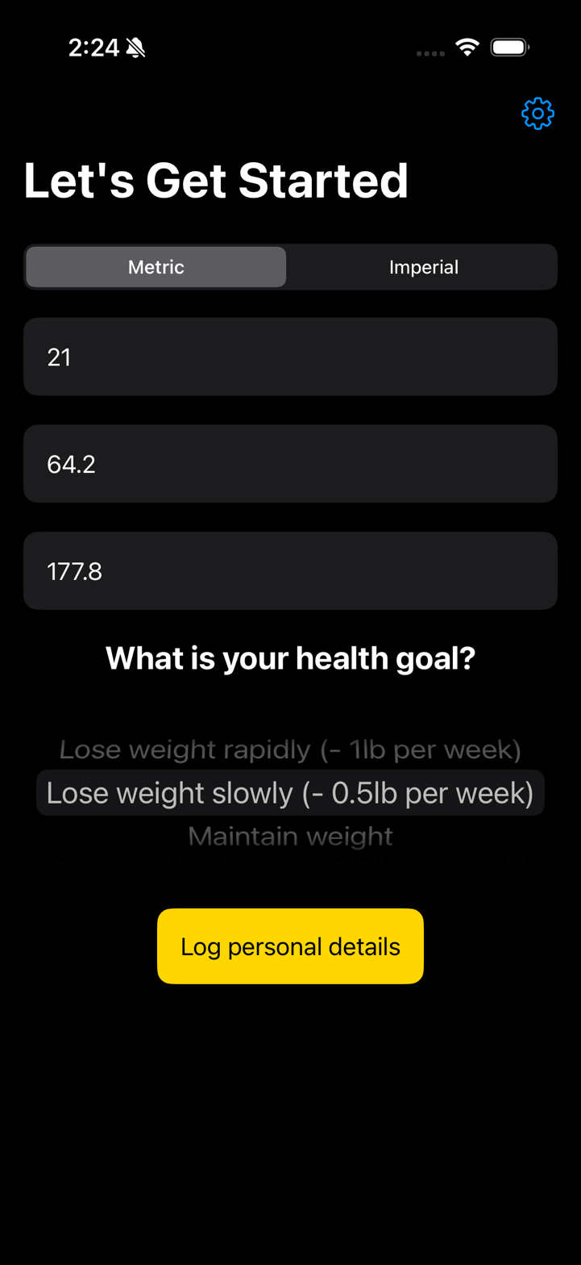

Figure 32: Automatic metric conversion with health goal displayed on home page #1 and #2

This artifact documents a milestone in the project. It explains progress and how it fits into the overall deliverable (see Figure 33).

GitHub link to full document :

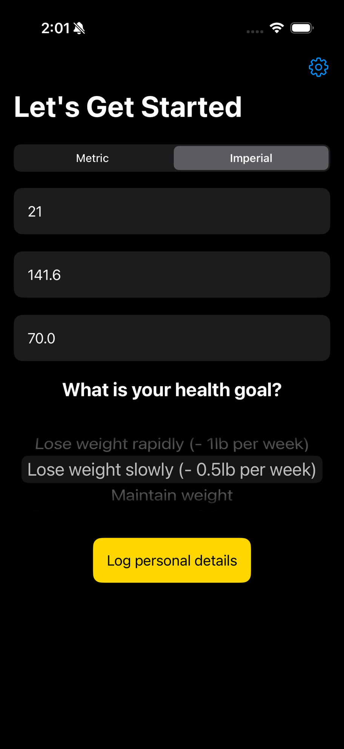

Figure 33: Artifact 33

This artifact documents the development environment setup in Xcode. It marks the transition from learning to building the project (see Figure 34).

GitHub link to full document :

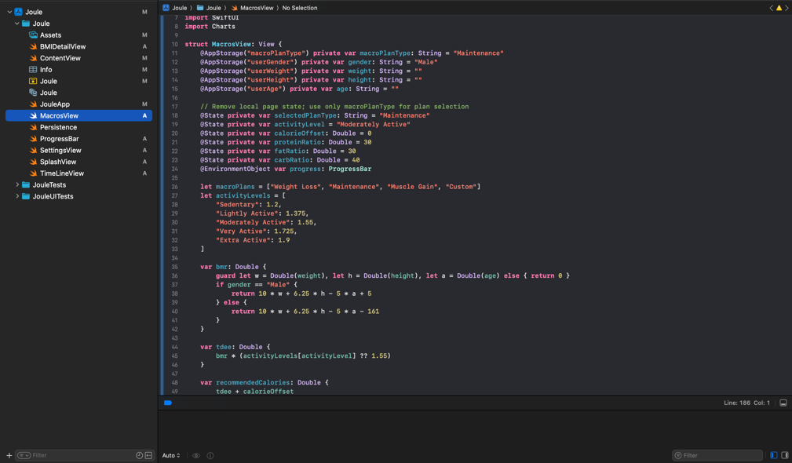

Figure 34: Xcode code reorganization screenshots #1, #2 and #3

This artifact documents a milestone in the project. It explains progress and how it fits into the overall deliverable (see Figure 35).

GitHub link to full document :

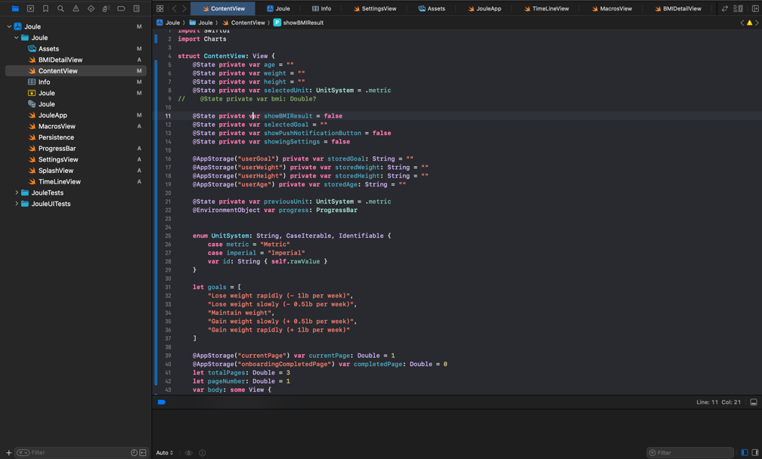

Figure 35: Artifact 35

This artifact documents a milestone in the project. It explains progress and how it fits into the overall deliverable (see Figure 36).

GitHub link to full document :

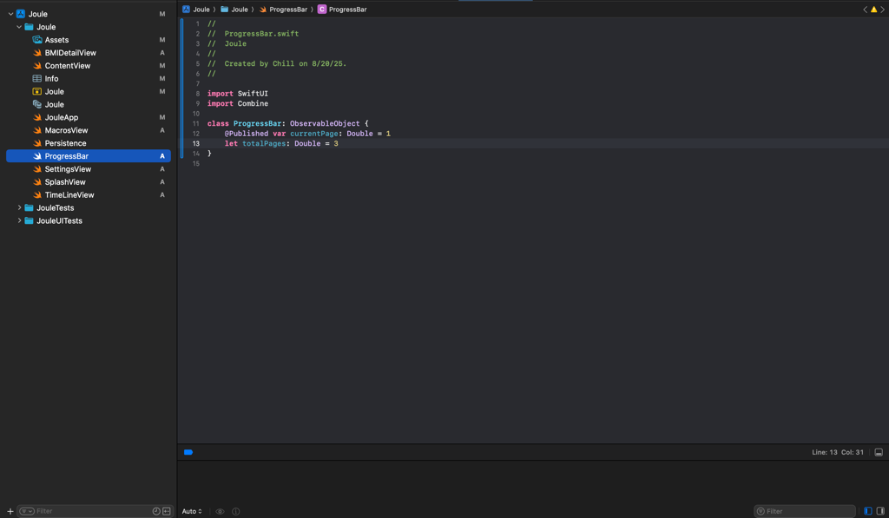

Figure 36: Artifact 36

This artifact shows progress through structured learning resources. These lessons directly shaped code structure and UI patterns in the app (see Figure 37).

GitHub link to full document :

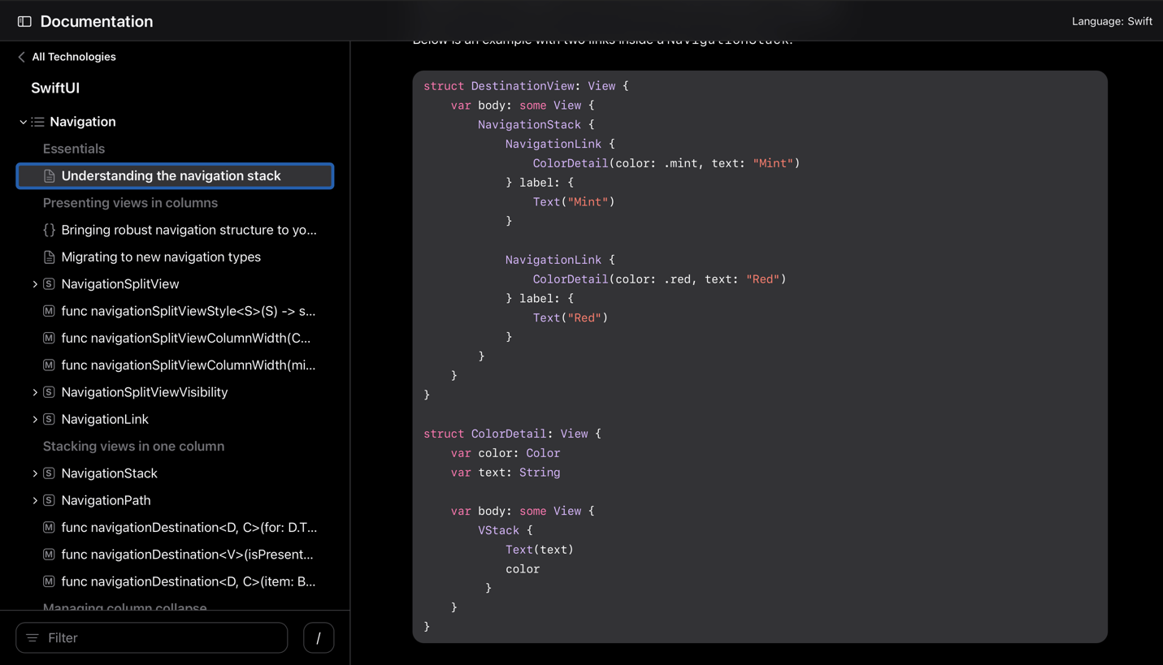Figure 37: SwiftUI documentation research

This artifact documents a milestone in the project. It explains progress and how it fits into the overall deliverable (see Figure 38).

GitHub link to full document :

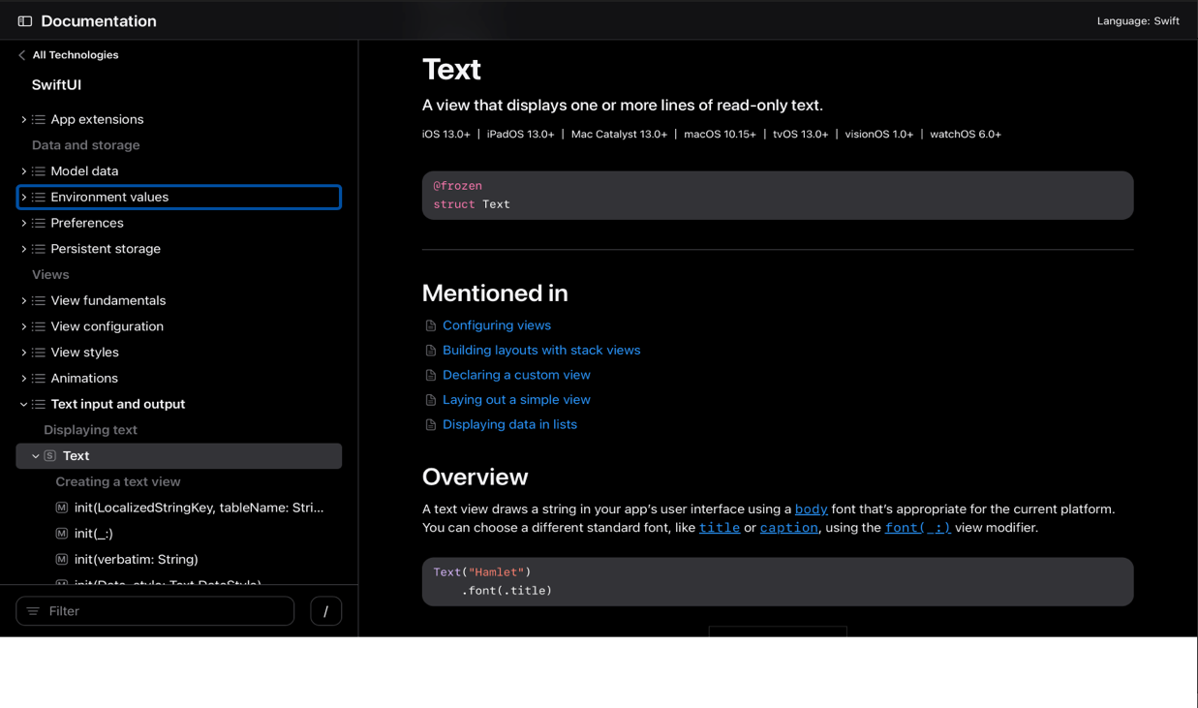

Figure 38: Artifact 38

This artifact covers the app icon and launch screen design. It contributed to cohesive branding and a polished first impression (see Figure 39).

GitHub link to full document :

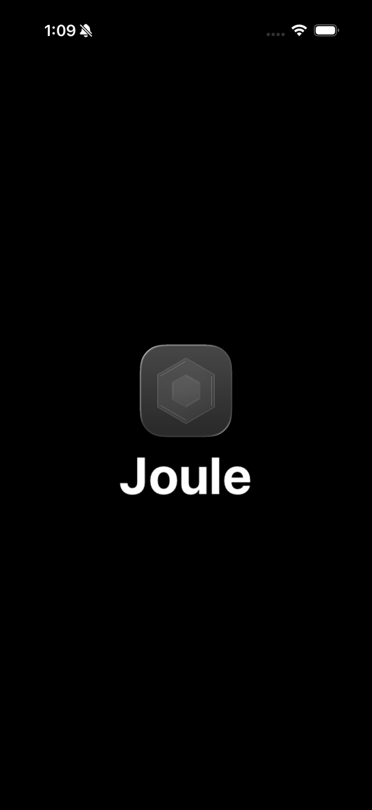

Figure 39: App Icon with launch screen

This artifact records minor UI bugs and fixes applied. It shows iteration and attention to polish (see Figure 40).

GitHub link to full document :

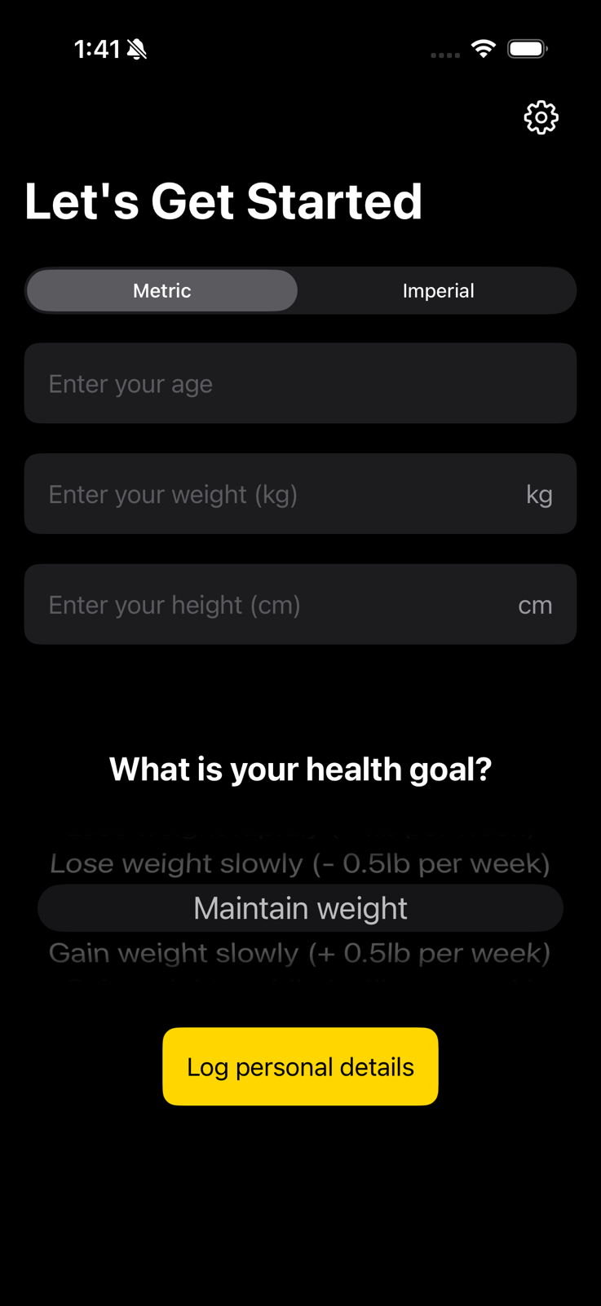

Figure 40: Minor UI bug fixes

This artifact documents a milestone in the project. It explains progress and how it fits into the overall deliverable (see Figure 41).

GitHub link to full document :

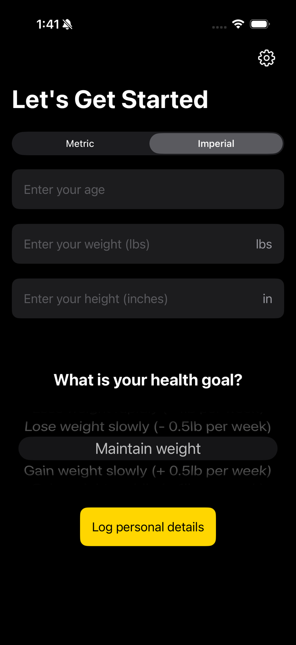

Figure 41: Artifact 41

This artifact shows the progress bar implementation. It provides feedback on task/goal completion to the user (see Figure 42).

GitHub link to full document :

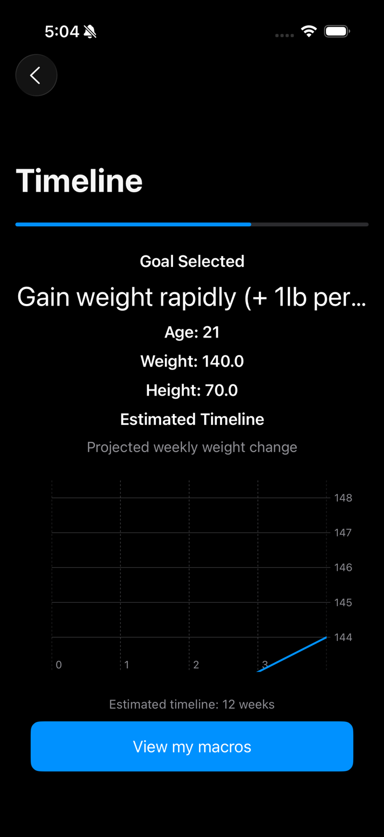

Figure 42: Progress bar implementation

This artifact documents a milestone in the project. It explains progress and how it fits into the overall deliverable (see Figure 43).

GitHub link to full document :

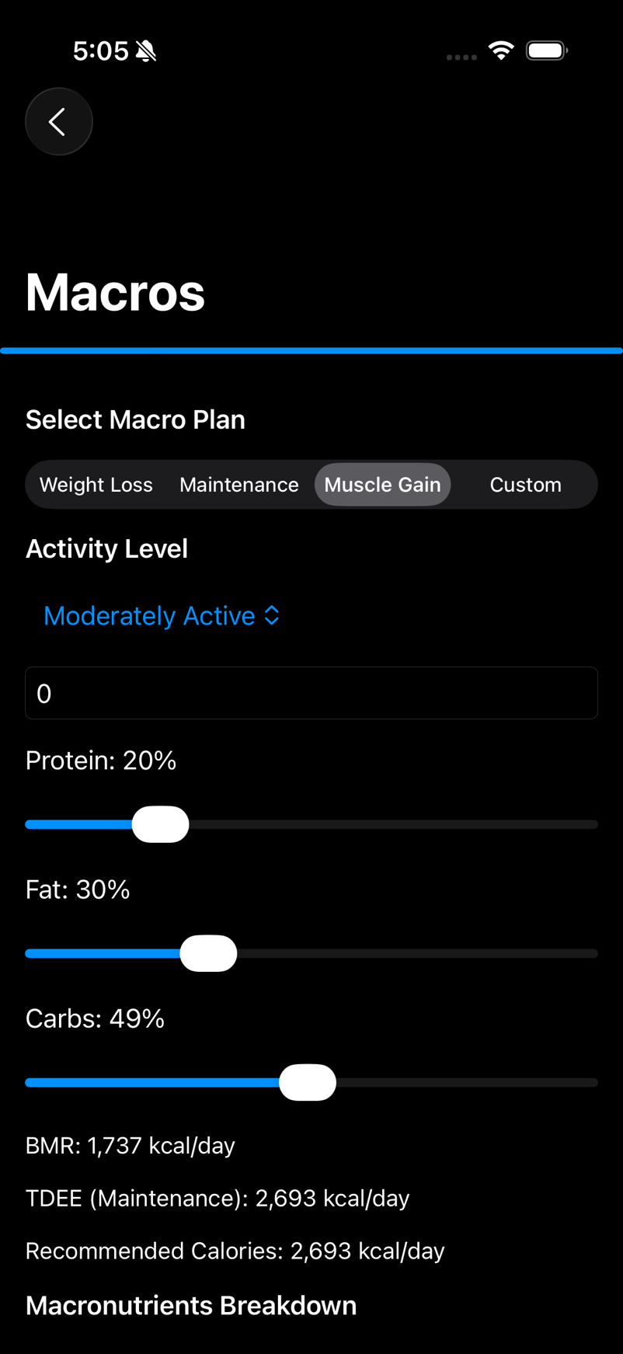

Figure 43: Artifact 43

This artifact documents a milestone in the project. It explains progress and how it fits into the overall deliverable (see Figure 44).

GitHub link to full document :

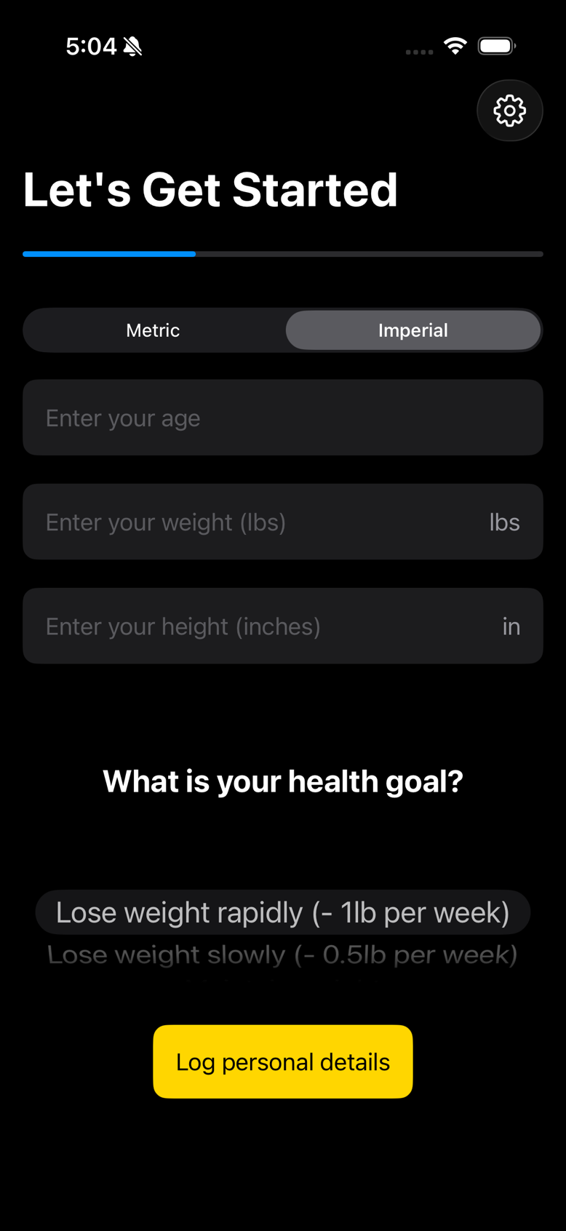

Figure 44: Artifact 44

# UI Design Artifacts

This artifact comes from my Figma workspace where I shaped wireframes and flows. It ensured clarity before coding views in SwiftUI (see Figure 45).

GitHub link to full document :

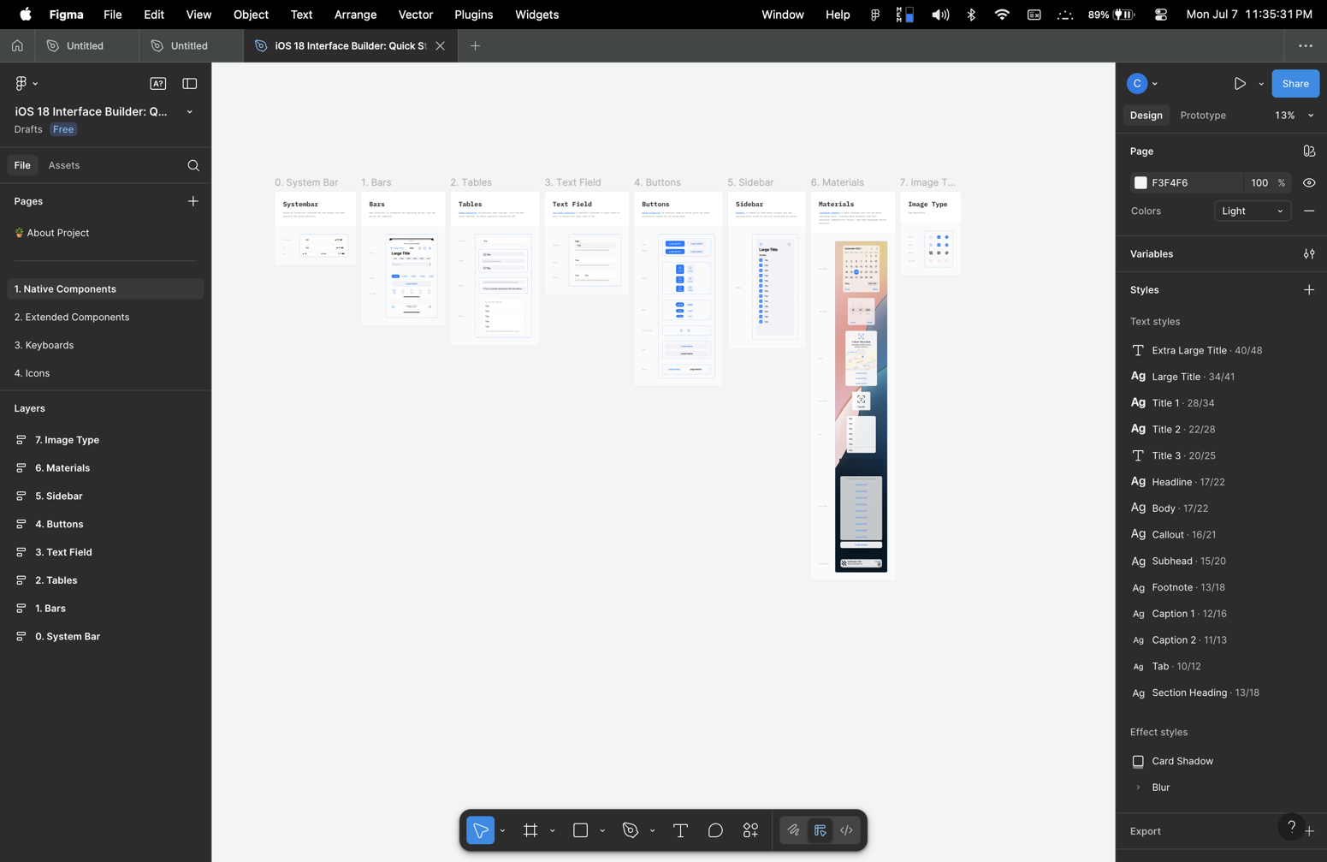Figure 45: Figma screenshot of blueprints for iOS UI development

This artifact covers the app icon and launch screen design. It contributed to cohesive branding and a polished first impression (see Figure 46).

GitHub link to full document :

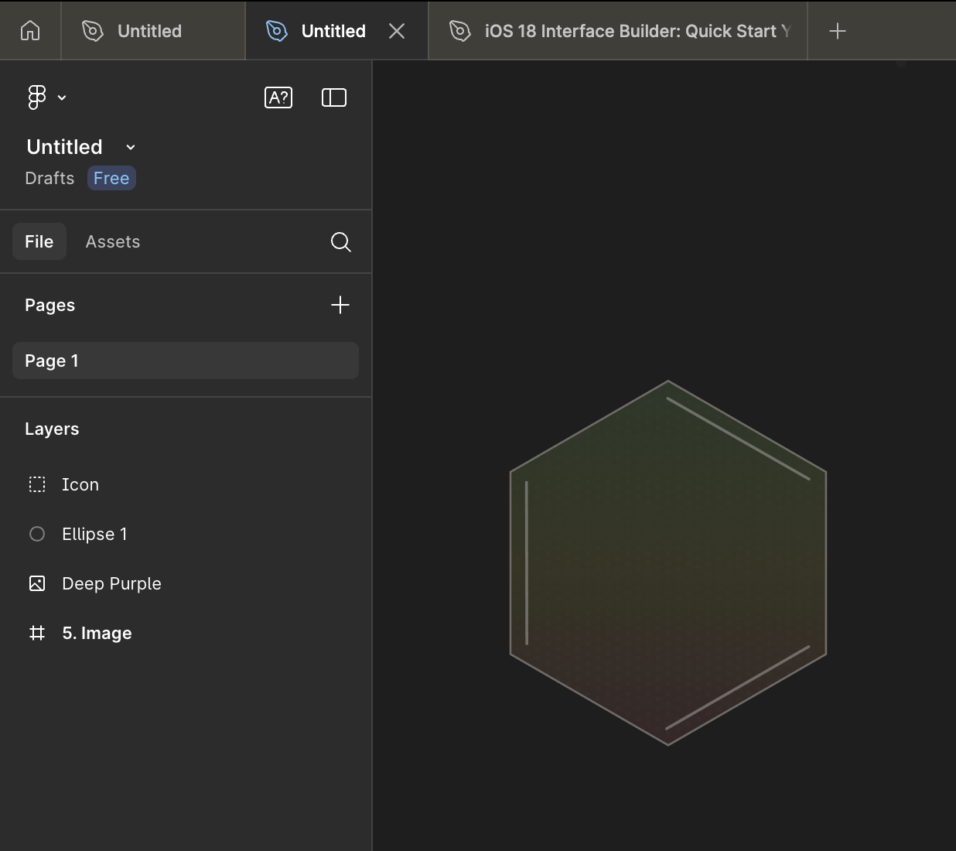Figure 46: Screenshot of designing the base for the icon in Figma